What is bin:

Where is bin in Mac:

cd /usr/local/bin

What is inside bin:

Python

Mysql

How to create a python program

First create a document: nano XXX.py

20:16:46 Wenyi@Wenyis-MacBook-Air.local:~

**nano hello.py**

**#!/usr/local/bin/python**

**def main():**

**print 'Hello world'**

**if __name__ == '__main__':**

**main()**

20:16:46 Wenyi@Wenyis-MacBook-Air.local:~

**python hello.py**

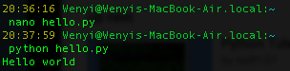

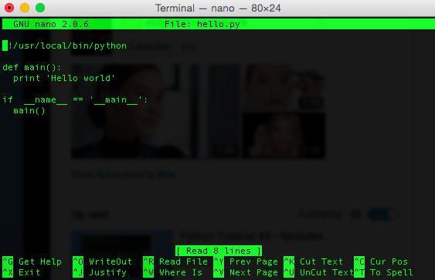

python

>>> import sys

>>> dir(sys)

>>> help(sys.exit)

>>> help(sys.argv)

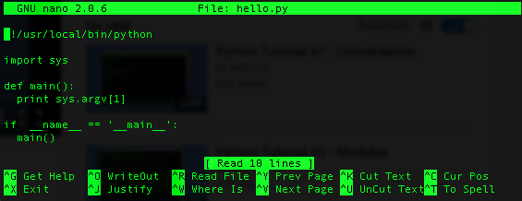



what is sudo

Wenyis-MacBook-Air:~ Wenyi$ ln -s /Applications/Sublime\ Text\ 2.app/Contents/SharedSupport/bin/subl /usr/local/bin/subl

Wenyis-MacBook-Air:~ Wenyi$ which subl

/usr/local/bin/subl

Wenyis-MacBook-Air:~ Wenyi$ subl hello.py

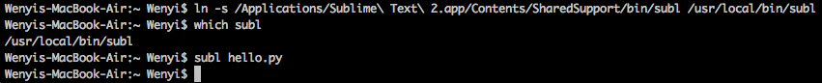

Wenyis-MacBook-Air:~ Wenyi$ ln -s /Applications/Sublime\ Text\ 2.app/Contents/SharedSupport/bin/subl /usr/local/bin/subl

Wenyis-MacBook-Air:~ Wenyi$ which subl

/usr/local/bin/subl

Wenyis-MacBook-Air:~ Wenyi$ subl hello.py

Wenyis-MacBook-Air:~ Wenyi$ cd Applications/